Practical - 14
Admin Dashboard with Role-Based Access Control, Dynamic Menu, and Audit Log
Problem Definition: Develop an admin dashboard that displays user statistics, student count, event count and latest registrations. Restrict access to admin users only and show dynamic menu options based on role.

A. Theory
1. What is an admin dashboard?
Answer: It is a central page that summarizes important system information and gives authorized administrators access to management tools.
2. What is role-based access control?
Answer: RBAC grants permissions according to roles. The server must check the role on every protected page and action.
3. Why load statistics dynamically?
Answer: Database-backed counts and recent records keep the dashboard current without manually editing page content.
4. What is an audit log?
Answer: An audit log records important actions, including who performed an action, what happened, which record was affected, and when it occurred.

B. Implementation / Procedure
1. Protect dashboard
Start the session and reject users who are not authenticated administrators before outputting dashboard data.
2. Query statistics
Use SQL COUNT queries for users, students, and events. Fetch the latest registrations with ORDER BY created_at DESC and a suitable LIMIT.
3. Dynamic menu
Build navigation based on the verified role and ensure each destination independently checks permissions.
4. Audit log schema
Create audit_logs with id, user_id, action, entity_type, entity_id, details, and created_at fields.
5. Record actions
After a successful administrative operation, insert an audit entry using a prepared statement. Avoid logging passwords, tokens, or other secrets.
6. Display dashboard
Use summary cards and a recent-registration table. Escape database content before rendering and show sensible empty/error states.

C. Test Cases
Test Case | Input / Action | Expected Result
Admin access | Log in as admin | Dashboard and admin menu appear
Student access | Log in as student and open admin URL | Access is denied or redirected
Dynamic counts | Add a student/event | Corresponding count changes
Audit logging | Perform an admin update | A log entry records the action and actor
Menu visibility | Compare admin and student roles | Only role-appropriate links are displayed

D. Key Questions / Analysis / Interpretation
1. Are dashboard values loaded dynamically from the database?
Answer: Yes. Counts and latest registrations are fetched using SQL queries so the dashboard reflects current database contents.
2. Is access restricted to admin users?
Answer: The server checks the authenticated user's role before showing the dashboard or processing admin actions. Hiding a menu item alone is not security.
3. Are role-based menus working?
Answer: Menu links are generated according to the user's role, showing only the options that role is allowed to use.
4. Are important admin actions recorded in audit_logs?
Answer: Actions such as creating, updating, or deleting events and changing student records can be logged with the actor, action, target, and timestamp.

M. Evidence of Work (Screenshots)
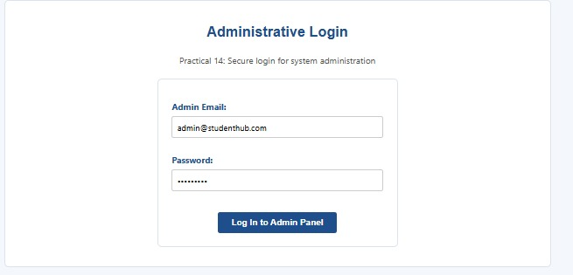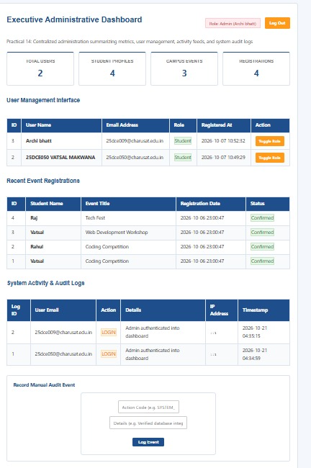
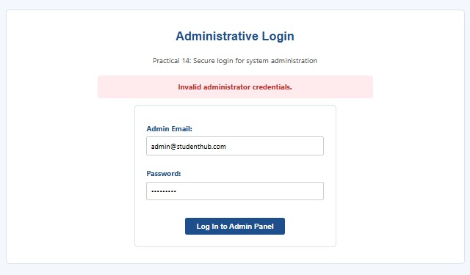

N. GitHub Repository Link
https://github.com/archibhatt091601/studenthub-ortal

